To correct errors in connecting to published web service, do the following:

Run Command Prompt with elevated permissions and type the following:

%windir%\Microsoft.NET\Framework\v4.0.30319\aspnet_regiis.exe -i

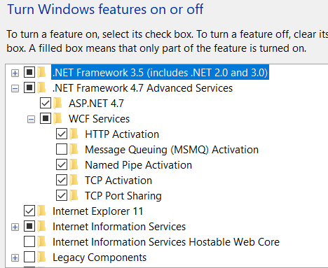

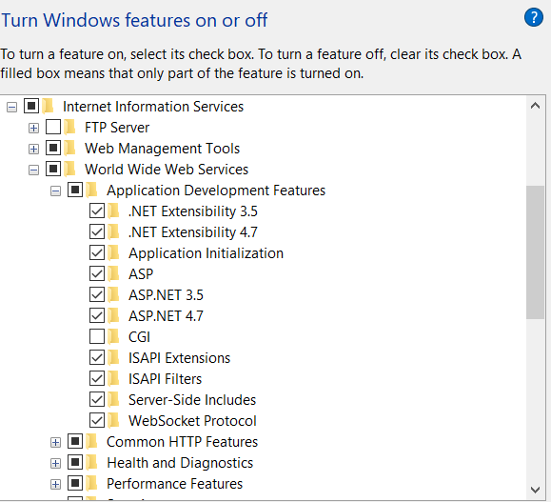

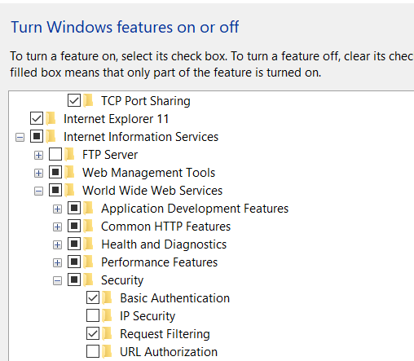

Open SQL Server Management Studio and run the following script:

IF NOT EXISTS (SELECT name FROM sys.server_principals WHERE name = 'IIS APPPOOL\DefaultAppPool')

BEGIN

CREATE LOGIN [IIS APPPOOL\DefaultAppPool]

FROM WINDOWS WITH DEFAULT_DATABASE=[master],

DEFAULT_LANGUAGE=[us_english]

END

GO

CREATE USER [WebDatabaseUser]

FOR LOGIN [IIS APPPOOL\DefaultAppPool]

GO

EXEC sp_addrolemember 'db_owner', 'WebDatabaseUser'

GO

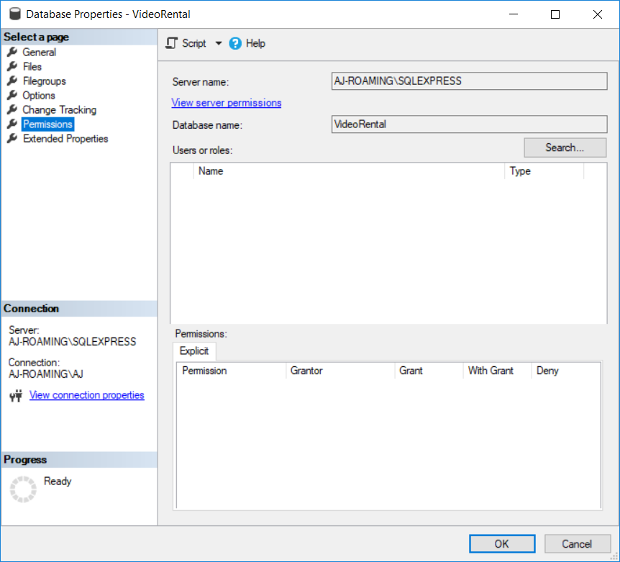

Click View Server Permissions and locate IIS AppPool and apply all permissions.

